CS 557

Homework #1

2/6/2018

Kayla Goetzke

Phil Sauvey

Chapter 1

1.1) The file contains 7 records (21-5Z through 31-7P). Each of the records is composed of 5 fields (PROJECT_CODE through PROJECT_BID_PRICE).

1.2) The is no city field so you would have to parse the city out of the address which can sometimes be problematic depending on formatting. If the MANAGER_ADDRESS field is broken up into Street Address, City, State, and Zip fields then it would make it easier to sort based on location

1.3) To produce those listings the MANAGER_ADDRESS field should be broken up into Street Address, City, State, and Zip fields, The PROJECT_MANAGER field should be split into a last name and first name field. I would split the area code out into its own field as well.

1.4) Data redundancy exists when the same data is stored unnecessarily at different places. For example, Holly B Parker occurs three times. That means that her name, address and phone number show up three times. They have to be careful if she moves or changes her phone number because all three fields must be changed correctly. If they miss a change, this creates a data anomaly. It might be difficult to know which is the correct data if they change it for one of her files but not the other. This would also be the case for George F. Dorts.

1.5)People are repeated more than once which may cause issues when updating information, It looks like the job code and charge hours are supposed to be directly related on a project, for example all people with the code CT charge 60.00 on project Hurricane, however on the Satellite project, there are two different charge hours, one is just the transposition of the numbers in the other, which makes me think there was a mistake when entering the data, which will definitely cause problems down the line. In my opinion, the PROJ_NAME and JOB_CHG_HOUR fields are unnecessary and just provide another chance for data to be inaccurate. The same could potentially be said about the EMP_NAME and EMP_PHONE fields in this table.

Chapter 2

2.1) One agent can have many customers, but one customer only has one agent.

2.2)

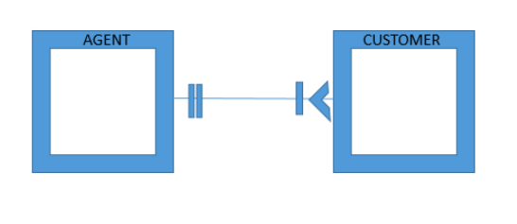

2.3)



Object Representation and UML Class Diagram

2.4) The relationship between REGION and STORE would be 1:M (one-to-many) because one region can be a location to many stores but a store can be in only one region. Next, the relationship between STORE and EMPLOYEE could be 1:M (one-to-many). We would need to implement a business rule saying that an employee can only work at one store at a time otherwise it would be a M:N (many-to-many) relationship. This is because again each store employs more than one employee, but an employee can only work at one store. Lastly, JOB and EMPLOYEE would be 1:M (one-to-many). The job can be assigned to many employees, but the employee can only have one job. Of course, this would be assuming the the employee can only have one job.

2.5)

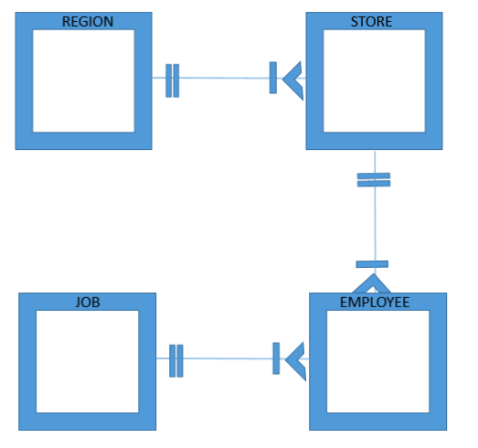

2.6) Course has a 1:M (one-to-many) relationship with class. Since a class can have many students, and each student may take many classes, there is a M:N (Many-to-Many) relationship between the two that is implemented with the enroll object . So the Business Relationships are:

Each COURSE generates many CLASSes, but each class is for a single course.

A CLASS may ENROLL many STUDENTS, and each STUDENT may ENROLL in many CLASSes

2.7)



2.9) (a) The business rules for PATIENT and ORDER would be that a patient can have multiple orders, but every order can only be assigned to one patient. Likewise, the relationship between ORDER and MEDICATION is 1:M. Therefore, an order can have more than one medication but each medication only belongs to one order.

2.9) (b)

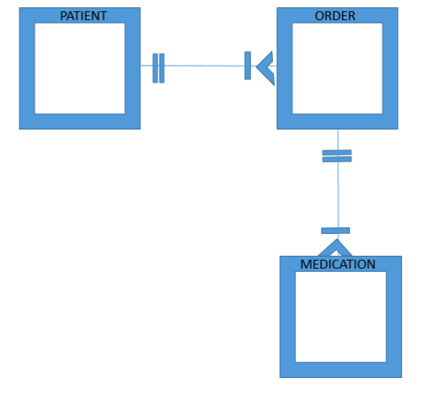

2.10) (a) Table PAINTER with the fields painter_id, first_name, last_name, phone_number, street_address, city, state, and email

Table GALLERY with the fields gallery_id, name, phone_number, street_address, city, state, email, and point_of_contact

Table PAINTING with the fields painting_id, name, year, medium, short_description, price, painter_id, and gallery_id

2.10) (b) The painter and gallery tables would be linked through the PAINTING table which contains the painter_id of the painter who painted it, and the gallery_id where the painting is currently located, essentially creating a M:N relationship between painter and gallery. Each PAINTER can exhibit a PAINTING in multiple GALLERYs, and each GALLERY can display PAINTINGS by multiple PAINTERs.

2.14)

